Full Name: Evan Baesler
EEL 3135 (Fall 2025) – HW #01

Homework 01

HW Question #1: Use matlab to plot the following signals using the Cosine function:
- Sketch 2cos(5θ) for values of θ in the range −4π ≤ θ ≤ 4π
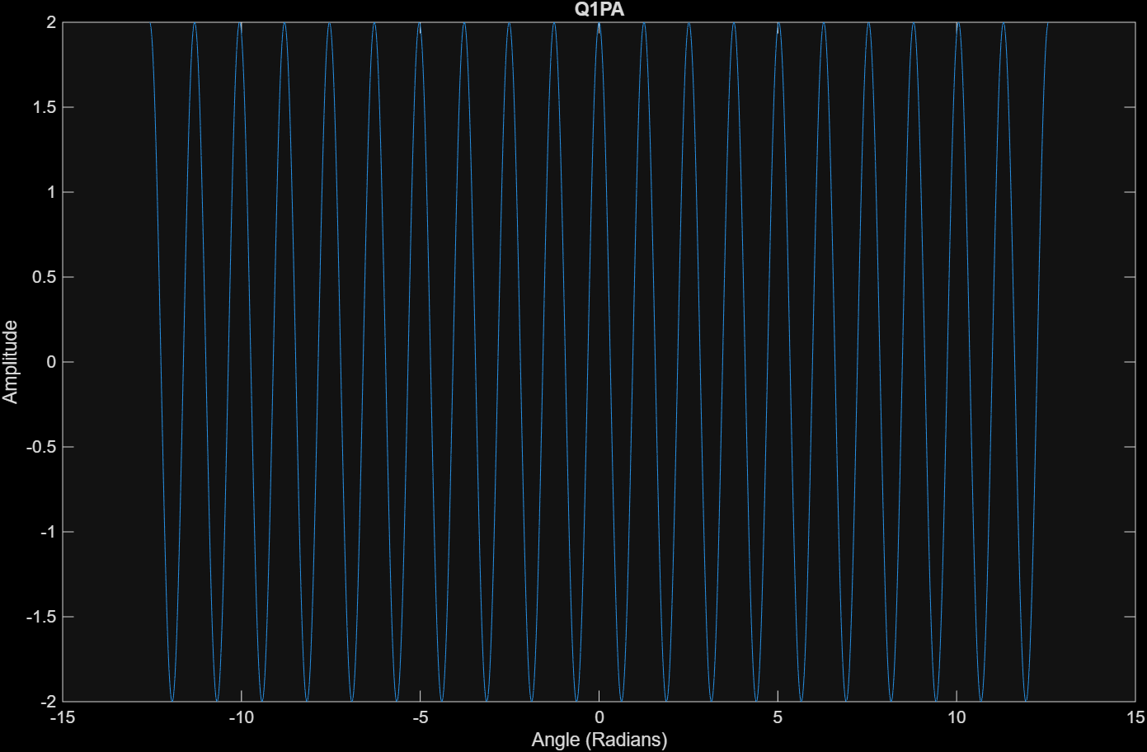
(b) Sketch cos(4πt) for values of t such that three full periods of the function are shown. Label the periods clearly.
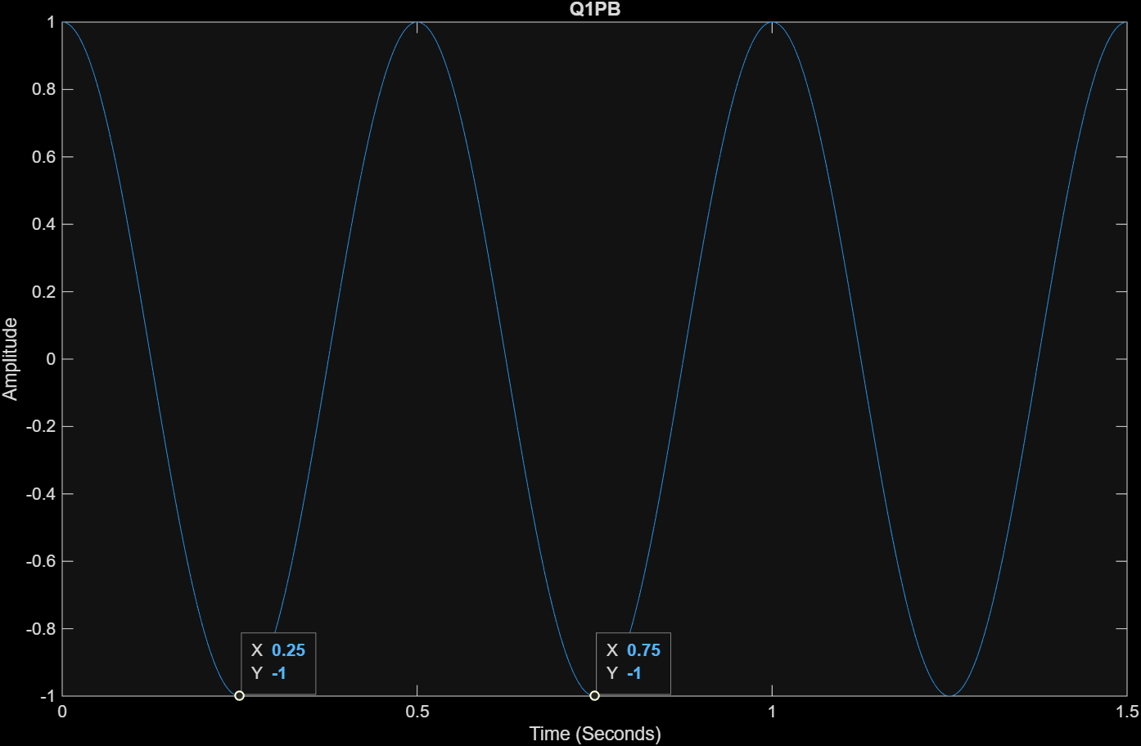
(c) Sketch cos(2πt/T₀ − π/2) for values of t such that −T₀ ≤ t ≤ T₀, with T₀ = 6. Label the horizontal axis in terms of the parameter T₀.
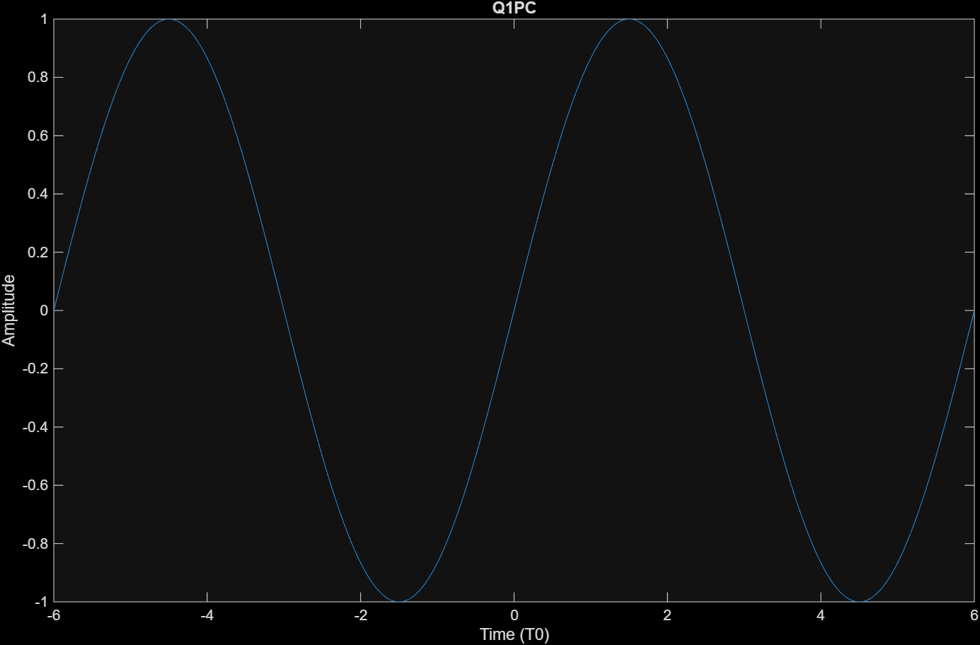

Use MATLAB for each case, include code and plots, and briefly discuss differences in amplitude, frequency, and phase effects.

For the amplitude, this is based on the coefficient of our cosine waves, in order it would be 2A, 1A, 1A amplitude. The frequency is determined by the coefficient to t in our waves.

For frequency: $f_{a}=\frac{5}{2π}Hz, f_{b}=\frac{4π}{2π}=2 Hz, f_{c}=\frac{1}{T_{0}}=\frac{1}{6}$
For phase: a and b had 0 phase, where c had a phase shift of $-\frac{π}{2}$, shifting it to the right.

Q1 CODE:
% Part 1
% Sketch 2 cos(5θ) for values of θ in the range −4π ≤ θ ≤ 4π

clear all;
close all;
clc;

figure;

A = 2;
fs = 1000;
dt = 1/fs;
theta = -4*pi:dt:(4*pi);
y = A*cos(5*theta);

plot(theta, y)
ylabel('Amplitude')
xlabel('Angle (Radians)')
title('Q1PA');

% Part 2

% Sketch cos(4πt) for values of t such that three full periods of the function are shown.
% Label the periods clearly.

figure;

A = 1;
fs = 1000;
dt = 1/fs;
t = 0*pi:dt:1.5; % T = 2*pi/w = (2*pi)/(4*pi) = 1/2
y = A*cos(4*pi*t);

plot(t, y)
ylabel('Amplitude')
xlabel('Time (Seconds)')
title('Q1PB')

% Part 3

% Sketch cos(2πt/T0 − π/2) for values of t such that −T0 ≤ t ≤ T0, with T0 = 6.
% Label the horizontal axis in terms of the parameter T0.

figure;

A = 1;
fs = 100;
dt = 1/fs;
T0 = 6;
t = -T0:dt:T0; % T = 2*pi/w = (2*pi)/(4*pi) = 1/2
y = A*cos(((2*pi*t)/T0)-pi/2);

plot(t, y)
ylabel('Amplitude')
xlabel('Time (T0)')
title('Q1PC')

HW Question #2: Reconstructing a Sinusoid A sinusoid has the following properties:
- Amplitude = 3
- Frequency = 8 Hz
- DC offset = +1
- At t=0, the signal equals its maximum value.
- Write the function x(t) in the form
x(t) = Acos(ω₀t + φ) + D.
$$x\left(t\right)=3\cos\left(8*2π*t+0\right)+1=3\cos\left(16πt\right)+1$$

- Plot the signal in MATLAB for 0 ≤ t ≤ 0.5 seconds.

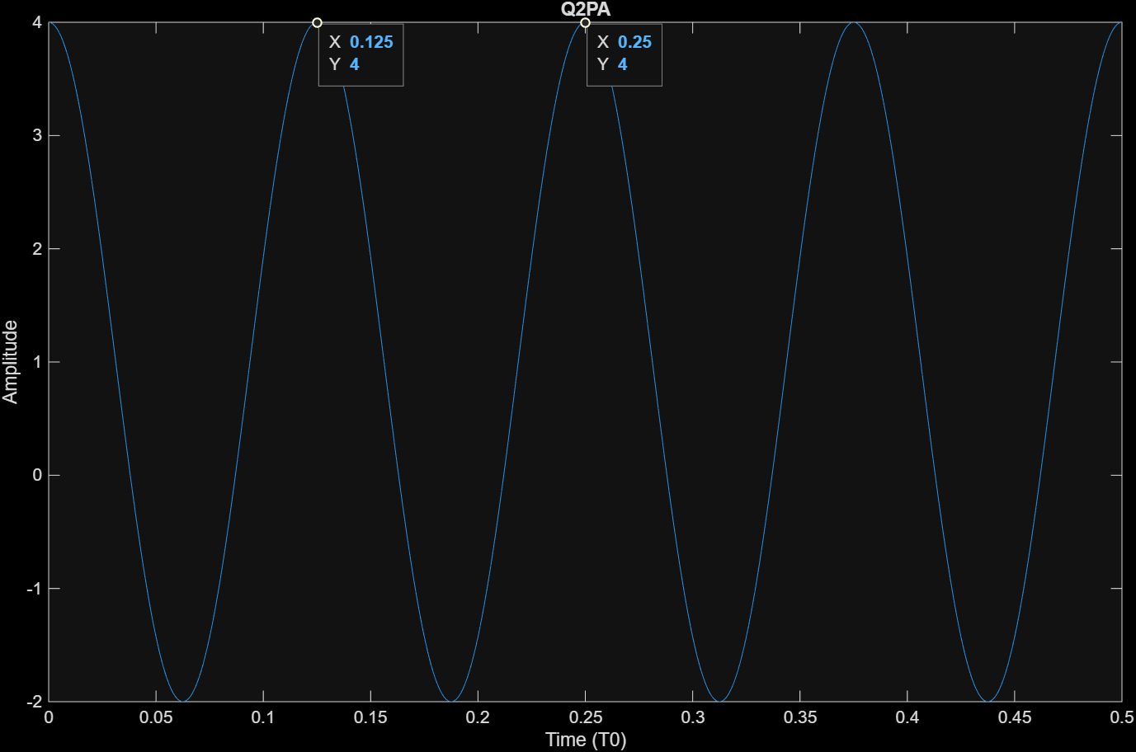

- Discuss how amplitude, frequency, and phase reveal themselves in your plot.

The wave goes from -2 to 4, which means we have an amplitude of 3 -> [(4 - -2)/2]. The frequency is 1/T which is $\frac{1}{0.125}=8Hz$, and a phase of 0 means we start at cos(0) or 1, 1 * 3 + 1 = 4.

Q2 CODE:

% A sinusoid has the following properties:
% • Amplitude = 3
% • Frequency = 8 Hz
% • DC offset = +1
% • At t=0, the signal equals its maximum value.
% Part 1
% Write the function x(t) in the form: x(t) = A cos(ω0t + φ) + D.

figure;

fs = 1000;
dt = 1/fs;

A = 3;
f = 8;
W0 = 2*f*pi;
D = 1;
t = 0:dt:0.5;
Phi = 0;

y = A*cos(W0*t + Phi) + D;

% Part 2
% Plot the signal in MATLAB for 0 <= t <= 0.5 seconds.

plot(t, y)
ylabel('Amplitude')
xlabel('Time (T0)')
title('Q2PA')

% Part 3
% Discuss how amplitude, frequency, and phase reveal themselves in your plot.
% Amplitude shows the maximum absolute value of the peaks/mins of the wave.
% Frequency is revealed because 1/8 = 0.125 seconds, our gap between peaks.
% Our phase is zero, so our cosine wave has cos(0) = 1A + D, or 3+1 = 4.

HW Question #3: Two phasors are defined as:
z_{A} = 3 + 4j z_{B} = −2 + 5j
rotating at 5Hz.

Complete the following using calculations by hand:
- Plot z_{A} and z_{B} using MATLAB’s compass function. Image of all phasors below
- Find z_{s} = z_{A} + z_{B}.
$$z_{s}=3-2+4j+5j=1+9j \left(Rectangular\right)$$
- Express in rectangular and polar form z_{s}
${|z}_{s}|=\sqrt{1^{2}+9^{2}}=\sqrt{82}≅9.055$, $∠=\arctan\left(\frac{9}{1}\right)≅1.46\frac{rads}{s}→z_{s}= 9.055∠1.46\frac{rads}{s}$ (Polar)
- Now plot z_{s} = z_{A} + z_{B} using MATLAB and check your work. Image of all phasors below
- Analyze z_{s}, what is the cosine function the would describe it?

$$Y=\left|z_{s}\right|*\cos\left(ω_{0}t+ϕ\right)=9.055cos\left(31.416t+1.460\right) (in \frac{rads}{s})$$

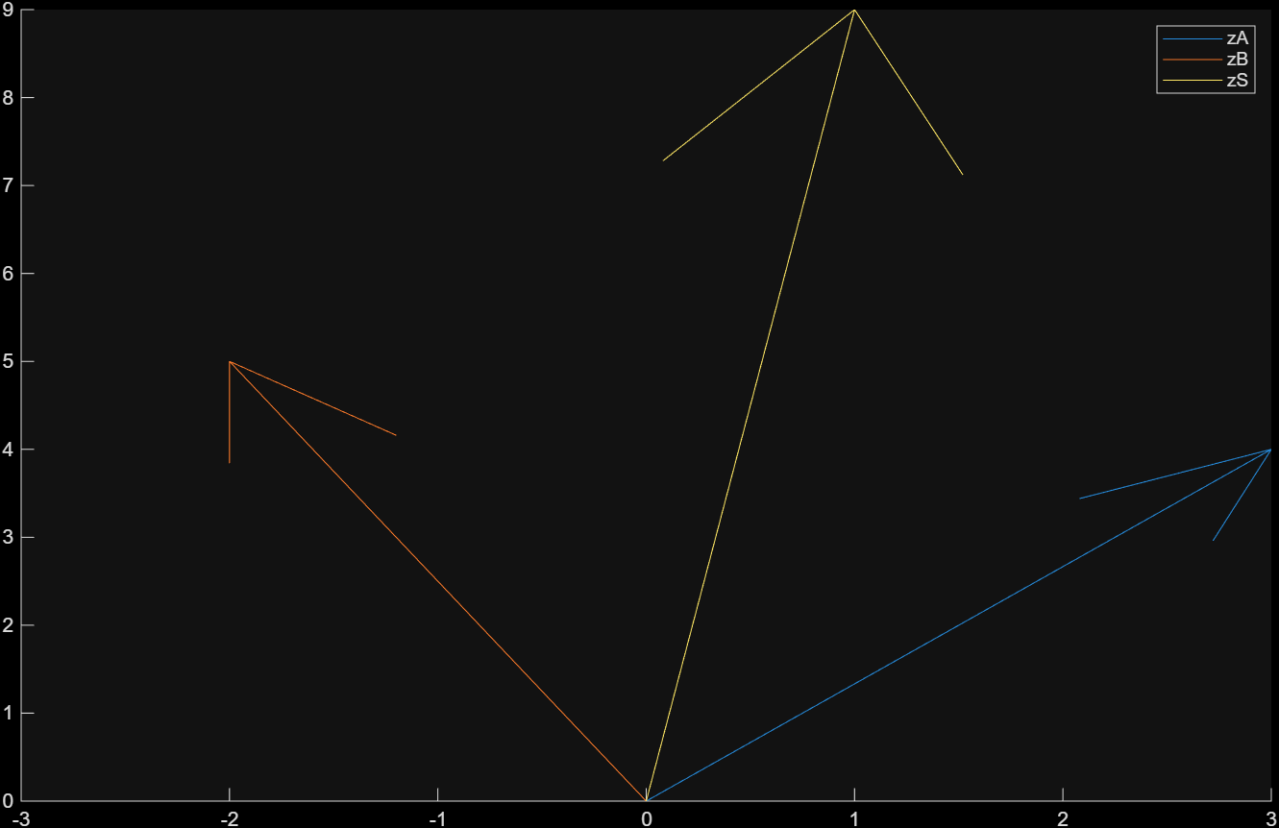

Q3 CODE:

% Part 1

zA = 3 + 4j;
zB = -2 + 5j;
% Rotating at 5 Hz

figure;
hold on;

f = 5;

compass(zA)
compass(zB)

zS = zA + zB; % This is 3-2 + 4j + 5j = 1 + 9j in rectangular.
compass(zS)
legend

hold off;

HW Question #4: Complex Sinusoid Representation
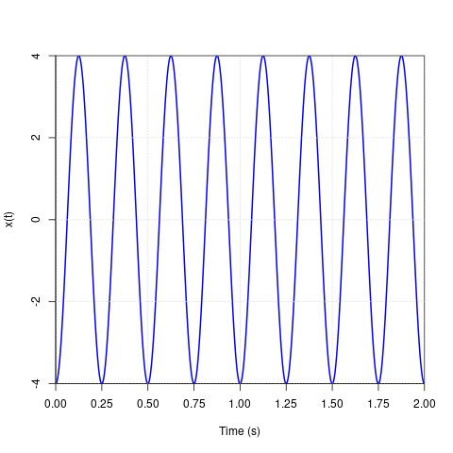
- Find the equation for the complex sinusoid. Write the function x(t) in the form
x(t) = Acos(ω₀t + φ) + D.
x(t) = $4\cos\left(8πt± π\right)+0$
- For the sinusoidal waveform shown, determine the complex phasor representation X = Ae^{jφ} by finding the values of the parameters ω₀, φ, and A such that the waveform is represented by
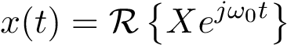 = $R\{4e^{j8πt+π}\}$
- Plot real and imaginary component of the function.
Y(t) = $4*\left[\cos\left(8πt+π\right)+jsin\left(8πt+π\right)\right]$
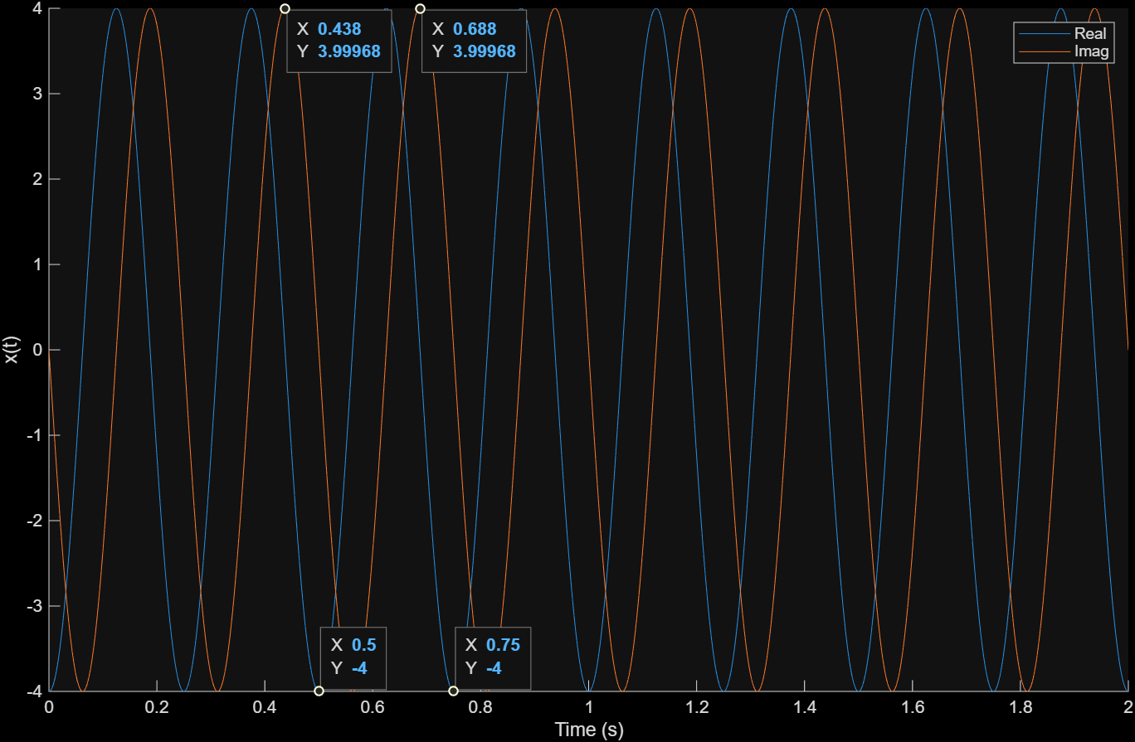
Q4 CODE:

% Part 3

fs = 1000;
dt = 1/fs;

A = 4;
f = 4;
W0 = 2*f*pi;
t = 0:dt:2;
Phi = pi;

figure;
hold on;

realcomp = 4*cos(W0*t+pi)
imagcomp = 4*sin(W0*t+pi)

plot(t, realcomp)
plot(t, imagcomp)
ylabel('x(t)')
xlabel('Time (s)')
legend;

hold off;

HW Question #5: Simplify the following sum:
5cos(40πt + π/6) + 2cos(40πt − π/3) (1)
- Add the two sinusoids and express it in form of Acos(2πft + φ) using the complex sinusoids formula (e^{jθ}).
$$5\cos\left(40πt+\frac{π}{6}\right)=5e^{j\frac{π}{6}} | 2\cos\left(40πt-\frac{π}{3}\right)= 2e^{-j\frac{π}{3}}$$
This gives us:
$$5e^{j\frac{π}{6}}=5\cos\left(\frac{π}{6}\right)+5jsin\left(\frac{π}{6}\right) and 2e^{-j\frac{π}{3}}=2\cos\left(-\frac{π}{3}\right)+2jsin(-\frac{π}{3})$$
Which is equivalent to:
$$5e^{j\frac{π}{6}}= 5\left(\frac{\sqrt{3}}{2}\right)+5\left(j\frac{1}{2}\right)=\frac{5\sqrt{3}}{2}+j\frac{5}{2} and 2e^{-j\frac{π}{3}}=2\left(\frac{1}{2}\right)-2\left(j\frac{\sqrt{3}}{2}\right)=1-j\sqrt{3}$$
Simplified:
$$\frac{5\sqrt{3}}{2}+1+j\frac{5}{2}-j\sqrt{3}≅5.330+j0.768$$
Magnitude:
$\sqrt{{\left(5.33\right)}^{2}+{\left(0.768\right)}^{2}}$ 5.385

Angle:
$$\arctan\left(\frac{0.768}{5.330}\right)≅0.143 rad$$
Final:
$$5.385cos⁡(2π*20*t+0.143)$$

- Verify your result in MATLAB by plotting both the original sum and your simplified expression on the same graph for time t between 0 and 0.25 seconds.

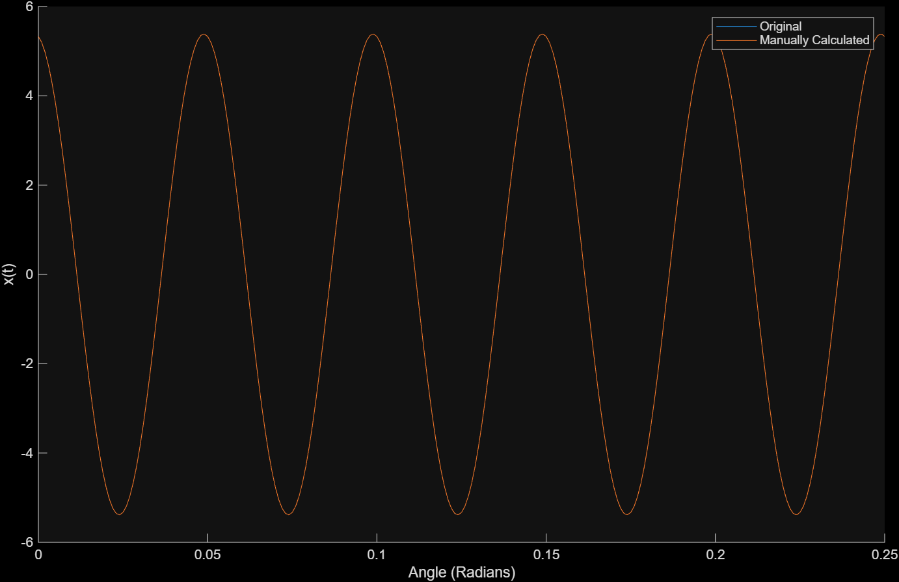
Q5 CODE:

% Part 2

fs = 1000;
dt = 1/fs;

A = 5.385;
f = 20;
W0 = 2*f*pi;
t = 0:dt:0.25;
Phi = 0.143;

waveSum1 = (5*cos(40*pi*t+(pi/6)) + 2*cos(40*pi*t - (pi/3)))

figure;
hold on;

plot(t, waveSum1)
plot(t, A*cos(W0*t+Phi))
ylabel('x(t)')
xlabel('Angle (Radians)')
legend('Original', 'Manually Calculated');

HW Question #6: Consider the following graph:
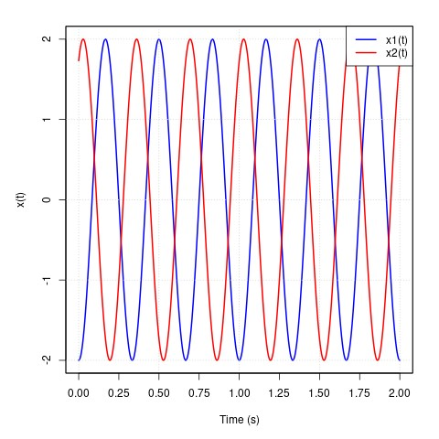
- Find the equation of the two complex sinusoids. Write the functions x1(t) and x2(t) in the form x(t) = Acos(ω₀t + φ) + D.

$$x1\left(t\right)=2\cos\left(12π\right), x2\left(t\right)=2cos⁡(12π+π)$$
- Add the two sinusoids x1(t) and x2(t), and express it in the form of Acos(2πft + φ) using the complex sinusoids formula (e^{jθ}).

$$x1\left(t\right)=2\left(\frac{\left(e^{j12π}+e^{-j12π}\right)}{2}\right)=\left(e^{j12π}+e^{-j12π}\right)$$
$$x2\left(t\right)=2\frac{\left(e^{j12π+π}+e^{-j12π+π}\right)}{2}=e^{j12π+π}+e^{-j12π+π}$$
Since they are offset by pi, the terms will cancel out, positive with positive and negative with negative. Net sum of 0; x1(t) + x2(t) = 0

- Now plot the sinusoids from part a and part b in MATLAB. You should have three sinusoids, x1(t) and x2(t), and the summation of both x1(t) and x2(t). In 2 to 3 sentences, explain how the addition of x1(t) and x2(t) leads to the construction or deconstruction of the resulting summation sinusoid (HINT: look at the phase).
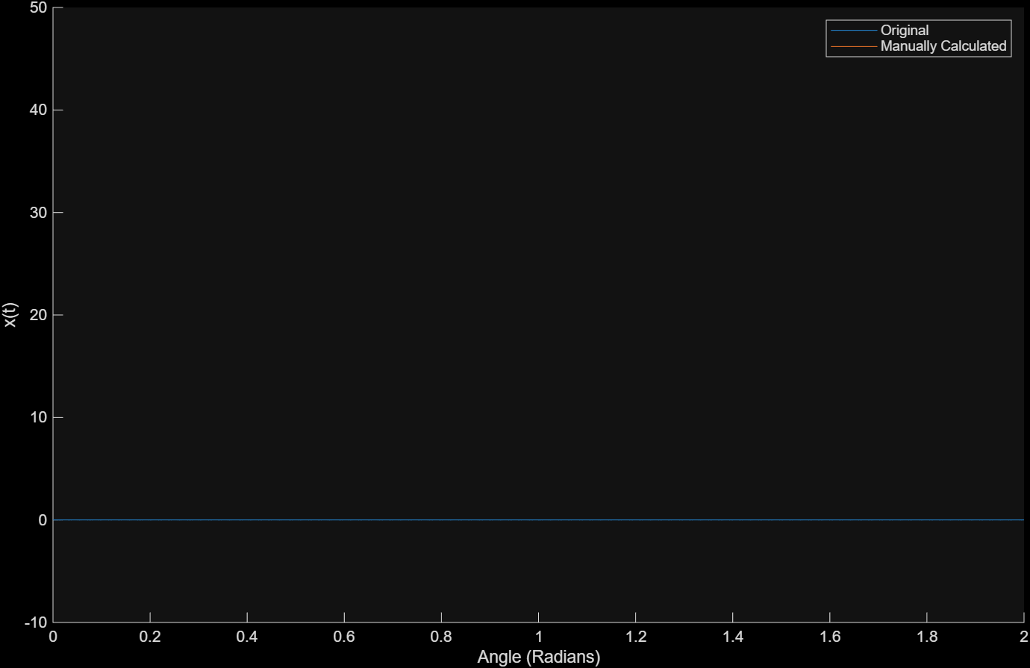

The two waves are offset from each other by 1 pi, causing them to cancel one another out. This is deconstruction, as we start with two distinct waves/data and end with a flatline. This happens because the term $e^{j12π}$ is canceled out by $e^{-j12π}$ and $e^{j12π+π}$ is canceled out by $e^{-j12π+π}$.

Q6 CODE:

% Part 3

fs = 1000;
dt = 1/fs;

A = 2;
f = 6;
W0 = 2*f*pi;
t = 0:dt:2;

waveSum2 = (2*cos(12*pi*t) + 2*cos(12*pi*t + (pi)))

figure;
hold on;

plot(t, waveSum2)
plot(t, (exp(j*12*pi) + exp(-1*j*12*pi) + exp(j*12*pi + pi) + exp(-1*j*12*pi + pi)))
ylabel('x(t)')
xlabel('Angle (Radians)')
legend('Original', 'Manually Calculated');

